Machine Description | Machine name / ID: Metasploitable2  Host / IP: 192.168.0.104  Operating System / Version: Ubuntu-based VM  Hostname: METASPLOITTABLE 2  Purpose / Role: Lab intentionally-vulnerable virtual machine used for penetration testing training and tool validation
Target IP | 192.168.0.104
Vulnerability Name | FTP vsftpd 2.3.4 — Remote Code Execution
Service/Version | TCP 21 /FTP
Severity | Critical
CVSS Score | 9.8
Attack Vector | CVSS:3.0/AV:N/AC:L/PR:N/UI:N/S:U/C:H/I:H/A:H
Poc | STEP 1 – HOST DISCOVERY USING NMAP  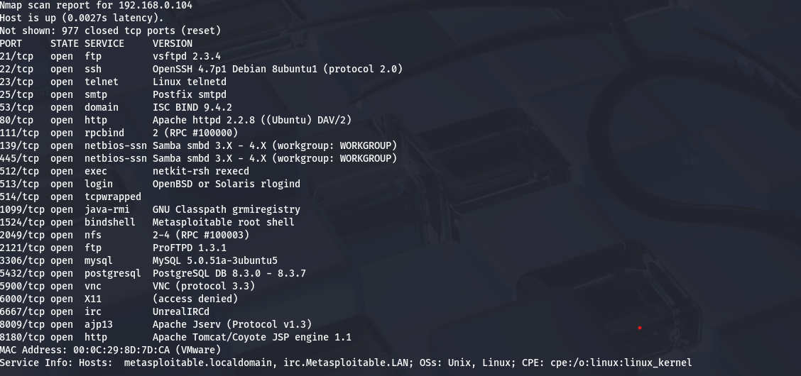  STEP 2- CONNECTION USING FTP CREDENTIALS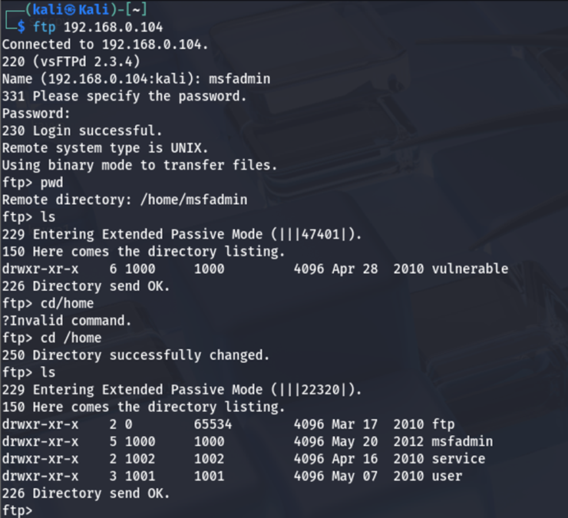  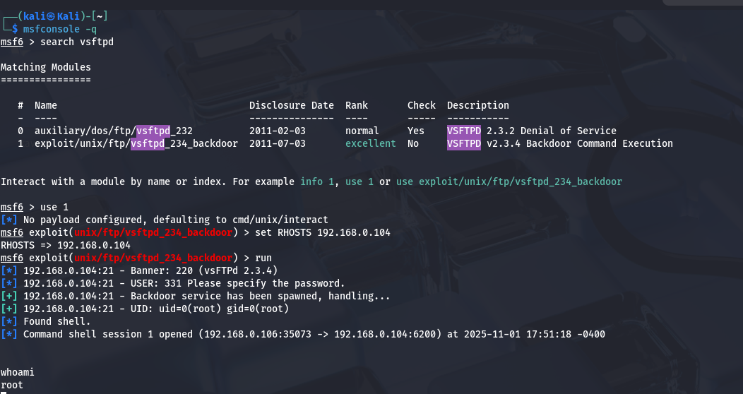  STEP 3- EXPLOITING FTP USING METASPOILT
IMPACT | • Remote code execution / shell access — full command execution on the host (vsftpd backdoor gives a shell; ProFTPD abuse can lead to RCE via a web payload).  • Privilege escalation / full system compromise — once a shell exists you can often escalate (local exploits, misconfigurations, root-owned writable files, or existing credentials). Metasploitable intentionally makes escalation trivial.  • Data theft, persistence, and pivoting — attacker can read files, create users/backdoors, drop web shells, and use the compromised VM to attack other hosts.
REFERENCE | NVD — CVE-2011-2523 (National Vulnerability Database). Official vulnerability record describing the backdoor that opens a shell on port 6200 and basic metadata. NVD  CVE.org — CVE Record for CVE-2011-2523. Canonical CVE entry (matching the NVD record). CVE  Rapid7 / Metasploit module — exploit/unix/ftp/vsftpd_234_backdoor. Metasploit module page with module description, usage, and references (useful for reproduction / commands run). Rapid7  Exploit-DB — vsftpd 2.3.4 Backdoor Command Execution (exploit entry). Archive of the exploit code / Metasploit module mirror and historical context. Exploit Database+1  Nmap NSE script — ftp-vsftpd-backdoor documentation / script. Script page & script source showing how detection can be automated (example nmap --script ftp-vsftpd-backdoor -p 21 <host>).  Why cite it: shows how to detect the backdoor in scanning workflows. Nmap+1
Target IP | 192.168.0.5
Vulnerability Name | vstpd 2.3.4 — Backdoor Command Execution
Service/Version | vsftpd 2.3.4 backdoor
Severity | Critical
CVSS Score | 9.8
Attack Vector | CVSS:3.0/AV:N/AC:L/PR:N/UI:N/S:U/C:H/I:H/A:H
Poc | 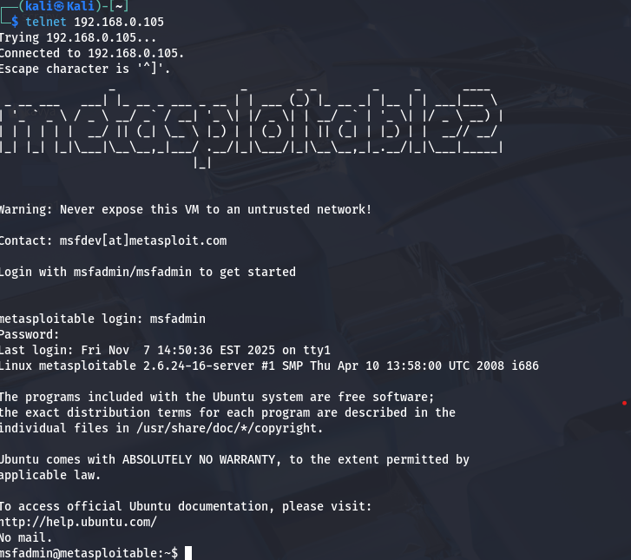
Impact | • Immediate: Remote unauthenticated command execution (interactive shell) — attacker can execute arbitrary commands.  • Potential: Full system compromise via local privilege escalation, persistence (users/web shells), data exfiltration, and lateral movement within the lab/network.
Reference | Exploit-DB — vsftpd 2.3.4 Backdoor Command Execution (exploit entry). Archive of the exploit code / Metasploit module mirror and historical context. Exploit Database+1  Nmap NSE script — ftp-vsftpd-backdoor documentation / script. Script page & script source showing how detection can be automated (example nmap --script ftp-vsftpd-backdoor -p 21 <host>).  Why cite it: shows how to detect the backdoor in scanning workflows. Nmap+1

